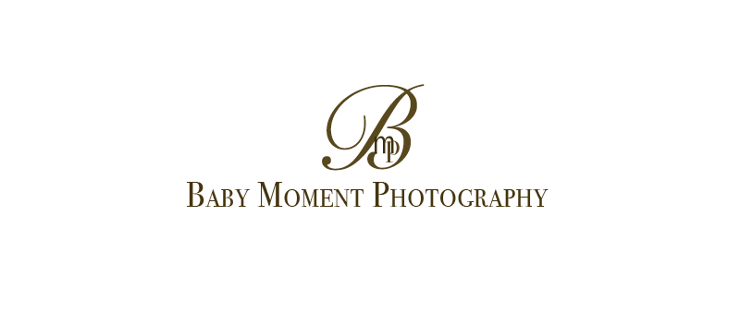

PHOTOGRAPHY SESSION CONTRACT

Note – For the purpose of this document Baby Moment Photography shall be referred to as Photographer. The visitor to the site or the individual (whether representing an organization or not) who orders an image shall be referred to as the Client.

1) APPLICABLE LAW

a) The laws of England and Wales shall govern this agreement. These Terms and Conditions shall not be varied except by agreement in writing.

b) In the event of any conflict between these terms and conditions (including those relating to the time of payment) and those issued or submitted by the Client and in the absence of any contrary agreement in writing these Terms and Conditions shall prevail.

2) BOOKING FEE

a) Upon booking, the Photographer will reserve the time and date agreed upon, and will not make other reservations for that time and date. The full amount of £70 is to be paid at the time of booking to secure your Portrait Photography Session. Client agrees if the balance is not paid at the time of booking, the Photographer cannot guarantee to attend your Portrait Session.

3) CANCELLATION/POSTPONEMENT

If the Client cancels the Portrait Photography Session, an unconditional refund policy exists up until 14 days prior to the reserved date, at which point the Photographer shall retain the full payment. Should the cancelled appointment turn out to be a postponement, then, subject to the Photographers availability, all monies paid may be applied to the new appointment. If the appointment has to be cancelled by the Photographer due to illness, adverse weather etc conditions a new, mutually agreed appointment will be made.

4) FULFILLMENT OF OBLIGATIONS

a) Photographer shall not be liable to the Client for any failure, in whole or in part, to fulfil its obligations where failure arises as a result of an event or circumstances beyond its control, which may include (but are not limited to) equipment failure.

b) The Client understands and accepts that the photographic coverage will be as Photographer's professional expertise determines. Special requests are not binding instructions although every effort is made to comply with the Client’s wishes.

c) In the unlikely event of total photographic failure or cancellation of the contract by either party or in any other circumstances the liability of one party to the other shall be limited to the total value of the contract. Neither party shall be liable for indirect or consequential losses

d) If Client fails to read the supplied PDF brochure, and therefore fails to carry out required preparations prior to a newborn session, Photographer will not be held responsible for any resulting reductions in quality or quantity of images supplied.

4) PRINTS.

All images produced by Photographer are printed on a fully calibrated monitor, and all prints will be a true reflection of the editing carried out by Photographer. Photographer will not be held responsible for variances in images caused by clients viewing images on non calibrated screens or monitors.

5) ARTISTIC INPUT

a) Save as otherwise agreed between the Client and Photographer, Photographer shall be entitled to use its judgment regarding the style and artistic input in the production of pictures. This includes but is not limited to locations, poses and number of images taken. Due to the vagaries of weather and the willingness of subjects it may not be possible to capture all the pictures requested, or images to the clients full expectations. In the event of uncooperative children at a session of any kind, for any reason, Photographer may not be able to capture any, or all the images the Client may have requested or expected. The Client is responsible for all older children at all times during sessions.

b) Photographer fully edits all images before presenting to Client.

6) COPYRIGHT & REPRODUCTION

a) Copyright is retained by Photographer at all times throughout the world. No image can be copied, scanned or reproduced in any form whatsoever without the prior consent of Photographer

b) The Client may not alter or add to or manipulate a picture by means of computer or any other technique or reproduce a picture in whole or in part as an element within, or as a montage with, another picture without Photographer's written permission.

c) Permission to reproduce a picture is granted to the Client by Photographer only when a fee for the reproduction has been agreed with Photographer and an invoice has been issued by Photographer and paid in full by the Client to Photographer.

d) In the event of unauthorized reproduction, the Client shall pay by way of liquidated damages to Photographer an unauthorized use fee of £100 per image, or double the standard reproduction fee for the use concerned, whichever is the greater.

e) The right to reproduce a picture granted by Photographer is personal to the Client and may not be assigned to any third party without prior written consent.

f) The Client will fully indemnify Photographer against any unauthorized reproduction of a picture submitted to the Client made by any third party as a result of or arising out of any breach by the Client of any of these terms and conditions (including but not by way of limitation the Client allowing a picture or a copy thereof to come into the possession of a third party without Photographer prior written consent).

7) IDENTIFICATION

a) While Photographer has taken reasonable care to correctly identify, caption and orientate the pictures, it does not accept any liability for loss or damage incurred by the Client or any third party caused by any errors.

8) RECEIPT OF PICTURES

a) The pictures are presumed to have been received in good condition unless the Client notifies Photographer in writing of any discrepancy or error within 14 days of receipt.

9) COOLING OFF PERIOD

a) Because the supply of the photographs has been made to the Client’s personal specification, (i.e. image number, print size, frame style, etc.), the Client does not have the right to a cooling off period.

b) By placing an order with Photographer, you are committing to buy the ordered products.

10) TAKING PHOTOGRAPHS DURING THE SESSION

A) Client is not allowed to take any photographs during the session with their phone or camera or any other equipment

11) USE OF PICTURES

a) Photographer, Paulina Kurdziel, retains the right in all cases to use the pictures in any manner at any time for the purposes of sales, advertising or promotion, of its work. No images will be taken, stored or published of a sensitive manner. Sensitive images include images of genitalia. Newborn buttocks are excluded from sensitive material.

11) IF ANY PROVISION OF THIS AGREEMENT IS HELD TO BE INVALID OR UNENFORCEABLE UNDER THE LAW, THE VALIDITY OF THIS AGREEMENT AS A WHOLE SHALL NOT BE AFFECTED, AND THE OTHER PROVISIONS OF THE AGREEMENT SHALL REMAIN IN FULL FORCE AND EFFECT.

IMAGES ARE KEPT FOR THE PERIOD AS DOCUMENTED BY PHOTOGRAPHER AT THE DISCRETION OF PHOTOGRAPHER, CLIENT ORDERS ARE REQUIRED WITHIN THE TIME PERIOD TOLD BY SP UPON GALLERY OPENING.

................................................ …..........................................

Client's Signature Baby Moment Photography